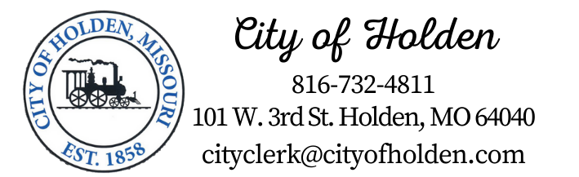

PUBLIC NOTICE

The Budget,Finance and Administration will hold a meeting on
April the 17th, 2024, beginning at 3:00 p.m.
The meeting will be held at Holden City Hall in the City Council Chambers,101 West 3rd Street, Holden, MO 64040. and possibly at site location, 611 East 10th Str, Holden MO 64040.
Copies of this notice can be made available to news media representatives by contacting the City Clerk via email: cityclerk@cityofholden.com or calling City Hall 816-732-4811

Posted by______________________

Date & Time Posted _________________

